# React Hooks

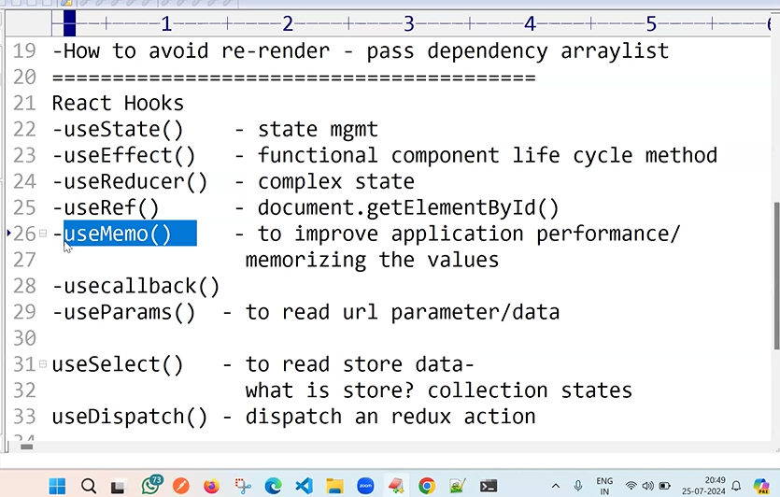

Useref()

Eye symbol - fontawesome